**Assignment: 11 Hash Table:**

**Input: keys 12, 44, 13, 88, 23, 94, 11, 39, 20, 16, and 5. Table Size 11**

1. **Perform linear probing on the above Input data with the given Table Size 11.**

**Solution: linear probing**

Table Size(N) = 11

Hash function h(k) = Key % N

|  |  |  |  |  |  |  |  |  |  |  |  |
| --- | --- | --- | --- | --- | --- | --- | --- | --- | --- | --- | --- |
| Key |  |  |  |  |  |  |  |  |  |  |  |
| Index | 0 | 1 | 2 | 3 | 4 | 5 | 6 | 7 | 8 | 9 | 10 |

**Insert(12):** 12 % 11 🡺1st index

|  |  |  |  |  |  |  |  |  |  |  |  |
| --- | --- | --- | --- | --- | --- | --- | --- | --- | --- | --- | --- |
| Key |  | 12 |  |  |  |  |  |  |  |  |  |
| Index | 0 | 1 | 2 | 3 | 4 | 5 | 6 | 7 | 8 | 9 | 10 |

**Insert(44):** 44 % 11 🡺0th index

|  |  |  |  |  |  |  |  |  |  |  |  |
| --- | --- | --- | --- | --- | --- | --- | --- | --- | --- | --- | --- |
| Key | 44 | 12 |  |  |  |  |  |  |  |  |  |
| Index | 0 | 1 | 2 | 3 | 4 | 5 | 6 | 7 | 8 | 9 | 10 |

**Insert(13):** 13 % 11 🡺2nd index

|  |  |  |  |  |  |  |  |  |  |  |  |
| --- | --- | --- | --- | --- | --- | --- | --- | --- | --- | --- | --- |
| Key | 44 | 12 | 13 |  |  |  |  |  |  |  |  |
| Index | 0 | 1 | 2 | 3 | 4 | 5 | 6 | 7 | 8 | 9 | 10 |

**Insert(88):** 88 % 11 🡺 0th index, since 0th index is already occupied we are going to move to next index until finds empty. So inserting 88 at 3rd index.

|  |  |  |  |  |  |  |  |  |  |  |  |
| --- | --- | --- | --- | --- | --- | --- | --- | --- | --- | --- | --- |
| Key | 44 | 12 | 13 | 88 |  |  |  |  |  |  |  |
| Index | 0 | 1 | 2 | 3 | 4 | 5 | 6 | 7 | 8 | 9 | 10 |

**Insert(23):** 23 % 11 🡺 1st index, since 1st index is already occupied we are going to keep move to next index until finds empty. So inserting 23 at 4rd index.

|  |  |  |  |  |  |  |  |  |  |  |  |
| --- | --- | --- | --- | --- | --- | --- | --- | --- | --- | --- | --- |
| Key | 44 | 12 | 13 | 88 | 23 |  |  |  |  |  |  |
| Index | 0 | 1 | 2 | 3 | 4 | 5 | 6 | 7 | 8 | 9 | 10 |

**Insert(94):** 94 % 11 🡺94-88 = 6st index.

|  |  |  |  |  |  |  |  |  |  |  |  |
| --- | --- | --- | --- | --- | --- | --- | --- | --- | --- | --- | --- |
| Key | 44 | 12 | 13 | 88 | 23 |  | 94 |  |  |  |  |
| Index | 0 | 1 | 2 | 3 | 4 | 5 | 6 | 7 | 8 | 9 | 10 |

**Insert(11):** 11 % 11 🡺 0th index, since 0th index is already occupied we are going to keep move to next index until finds empty. So inserting 11 at 5th index.

|  |  |  |  |  |  |  |  |  |  |  |  |
| --- | --- | --- | --- | --- | --- | --- | --- | --- | --- | --- | --- |
| Key | 44 | 12 | 13 | 88 | 23 | 11 | 94 |  |  |  |  |
| Index | 0 | 1 | 2 | 3 | 4 | 5 | 6 | 7 | 8 | 9 | 10 |

**Insert(39):** 39 % 11 = 39-33 🡺 6th index, since 6th index is already occupied we are going to keep move to next index until finds empty. So inserting 39 at 7th index.

|  |  |  |  |  |  |  |  |  |  |  |  |
| --- | --- | --- | --- | --- | --- | --- | --- | --- | --- | --- | --- |
| Key | 44 | 12 | 13 | 88 | 23 | 11 | 94 | 39 |  |  |  |
| Index | 0 | 1 | 2 | 3 | 4 | 5 | 6 | 7 | 8 | 9 | 10 |

**Insert(20):** 20 % 11 = 20-11 🡺 9th index.

|  |  |  |  |  |  |  |  |  |  |  |  |
| --- | --- | --- | --- | --- | --- | --- | --- | --- | --- | --- | --- |
| Key | 44 | 12 | 13 | 88 | 23 | 11 | 94 | 39 |  | 20 |  |
| Index | 0 | 1 | 2 | 3 | 4 | 5 | 6 | 7 | 8 | 9 | 10 |

**Insert(16):** 16 % 11 = 16-11 🡺 5th index. Now inserting 16 at index 8th index.

|  |  |  |  |  |  |  |  |  |  |  |  |
| --- | --- | --- | --- | --- | --- | --- | --- | --- | --- | --- | --- |
| Key | 44 | 12 | 13 | 88 | 23 | 11 | 94 | 39 | 16 | 20 |  |
| Index | 0 | 1 | 2 | 3 | 4 | 5 | 6 | 7 | 8 | 9 | 10 |

**Insert(5):** 5 % 11 =🡺 5th index. Now inserting 16 at index 10th index.

|  |  |  |  |  |  |  |  |  |  |  |  |
| --- | --- | --- | --- | --- | --- | --- | --- | --- | --- | --- | --- |
| Key | 44 | 12 | 13 | 88 | 23 | 11 | 94 | 39 | 16 | 20 | 5 |
| Index | 0 | 1 | 2 | 3 | 4 | 5 | 6 | 7 | 8 | 9 | 10 |

1. **Show the result of Input Keys, assuming collisions are handled by quadratic probing, up to the point where the method fails because no empty slot is found.**

**Solutions: Quadratic probing**

Input: keys 12, 44, 13, 88, 23, 94, 11, 39, 20, 16, and 5

Table Size(N) = 11

Hash function h(k) = Key % N

|  |  |  |  |  |  |  |  |  |  |  |  |
| --- | --- | --- | --- | --- | --- | --- | --- | --- | --- | --- | --- |
| Key |  |  |  |  |  |  |  |  |  |  |  |
| Index | 0 | 1 | 2 | 3 | 4 | 5 | 6 | 7 | 8 | 9 | 10 |

**Insert(12):** 12 % 11 🡺1st index

|  |  |  |  |  |  |  |  |  |  |  |  |
| --- | --- | --- | --- | --- | --- | --- | --- | --- | --- | --- | --- |
| Key |  | 12 |  |  |  |  |  |  |  |  |  |
| Index | 0 | 1 | 2 | 3 | 4 | 5 | 6 | 7 | 8 | 9 | 10 |

**Insert(44):** 44 % 11 🡺0th index

|  |  |  |  |  |  |  |  |  |  |  |  |
| --- | --- | --- | --- | --- | --- | --- | --- | --- | --- | --- | --- |
| Key | 44 | 12 |  |  |  |  |  |  |  |  |  |
| Index | 0 | 1 | 2 | 3 | 4 | 5 | 6 | 7 | 8 | 9 | 10 |

**Insert(13):** 13 % 11 🡺2nd index

|  |  |  |  |  |  |  |  |  |  |  |  |
| --- | --- | --- | --- | --- | --- | --- | --- | --- | --- | --- | --- |
| Key | 44 | 12 | 13 |  |  |  |  |  |  |  |  |
| Index | 0 | 1 | 2 | 3 | 4 | 5 | 6 | 7 | 8 | 9 | 10 |

**Insert(88):** 88 % 11 🡺 0th index, since 0th index is already occupied collusion occurs and is now solving using quadratic probing as follows,

Secondary hashing A[(i + j^2 ) mod N], j = 1,2,3,….

A[(0 + 1) % 11] = A[1], the slot is occupied at index 1

Now j =2, A[(0 + 4) % 11] = A[4], slot for index 4 is empty then inserted at 4th index.

|  |  |  |  |  |  |  |  |  |  |  |  |
| --- | --- | --- | --- | --- | --- | --- | --- | --- | --- | --- | --- |
| Key | 44 | 12 | 13 |  | 88 |  |  |  |  |  |  |
| Index | 0 | 1 | 2 | 3 | 4 | 5 | 6 | 7 | 8 | 9 | 10 |

**Insert(23):** 23 % 11 🡺 1st index, since 0th index is already occupied collusion occurs and is now solving using quadratic probing as follows,

Secondary hashing A[(i + j^2 ) mod N], j = 1,2,3,…. Where i = 1

A[(1 + 1) % 11] = A[2], the slot is occupied at index 2

Now j =2, A[(1 + 4) % 11] = A[5], slot for index 5 is empty then inserted at 5th index.

|  |  |  |  |  |  |  |  |  |  |  |  |
| --- | --- | --- | --- | --- | --- | --- | --- | --- | --- | --- | --- |
| Key | 44 | 12 | 13 |  | 88 | 23 |  |  |  |  |  |
| Index | 0 | 1 | 2 | 3 | 4 | 5 | 6 | 7 | 8 | 9 | 10 |

**Insert(94):** 94 % 11 🡺 6st index, since 6th index is empty then inserted.

|  |  |  |  |  |  |  |  |  |  |  |  |
| --- | --- | --- | --- | --- | --- | --- | --- | --- | --- | --- | --- |
| Key | 44 | 12 | 13 |  | 88 | 23 | 94 |  |  |  |  |
| Index | 0 | 1 | 2 | 3 | 4 | 5 | 6 | 7 | 8 | 9 | 10 |

**Insert(11):** 11 % 11 🡺 0st index, since 0th index is already occupied collusion occurs and is now solving using quadratic probing as follows,

Secondary hashing A[(i + j^2 ) mod N], j = 1,2,3,…. Where i = 0

A[(0 + 1) % 11] = A[1], the slot is occupied at index 1

Now j =2, A[(0 + 4) % 11] = A[4], slot 4th index is occupied.

Now j =3, A[(0 + 9) % 11] = A[9], slot 9th index is empty then inserted.

|  |  |  |  |  |  |  |  |  |  |  |  |
| --- | --- | --- | --- | --- | --- | --- | --- | --- | --- | --- | --- |
| Key | 44 | 12 | 13 |  | 88 | 23 | 94 |  |  | 11 |  |
| Index | 0 | 1 | 2 | 3 | 4 | 5 | 6 | 7 | 8 | 9 | 10 |

**Insert(39):** 39 % 11 = 39-33 🡺 6st index, since 6th index is already occupied collusion occurs and is now solving using quadratic probing as follows,

Secondary hashing A[(i + j^2 ) mod N], j = 1,2,3,…. Where i = 6

A[(6 + 1) % 11] = A[7], index 7th slot is empty so inserted.

|  |  |  |  |  |  |  |  |  |  |  |  |
| --- | --- | --- | --- | --- | --- | --- | --- | --- | --- | --- | --- |
| Key | 44 | 12 | 13 |  | 88 | 23 | 94 | 39 |  | 11 |  |
| Index | 0 | 1 | 2 | 3 | 4 | 5 | 6 | 7 | 8 | 9 | 10 |

**Insert(20):** 20 % 11 = 20-11 🡺 9st index, since 6th index is already occupied collusion occurs and is now solving using quadratic probing as follows,

Secondary hashing A[(i + j^2 ) mod N], j = 1,2,3,…. Where i = 9

A[(9+ 1) % 11] = A[10], index 10th slot is empty so inserted.

|  |  |  |  |  |  |  |  |  |  |  |  |
| --- | --- | --- | --- | --- | --- | --- | --- | --- | --- | --- | --- |
| Key | 44 | 12 | 13 |  | 88 | 23 | 94 | 39 |  | 11 | 20 |
| Index | 0 | 1 | 2 | 3 | 4 | 5 | 6 | 7 | 8 | 9 | 10 |

**Insert(16):** 16 % 11 = 16 -11 🡺 5st index, since 5th index is already occupied collusion occurs and is now solving using quadratic probing as follows,

Secondary hashing A[(i + j^2 ) mod N], j = 1,2,3,…. Where i = 5

A[(5+ 1) % 11] = A[6], index 6th slot is occupied.

Now j =2, A[(5 + 4) % 11] = A[9], slot 9th index is occupied.

Now j =3, A[(5 + 9) % 11] = 14-11 = 3, A[3], slot 3rd index is empty so inserted.

|  |  |  |  |  |  |  |  |  |  |  |  |
| --- | --- | --- | --- | --- | --- | --- | --- | --- | --- | --- | --- |
| Key | 44 | 12 | 13 | 16 | 88 | 23 | 94 | 39 |  | 11 | 20 |
| Index | 0 | 1 | 2 | 3 | 4 | 5 | 6 | 7 | 8 | 9 | 10 |

**Insert(5):** 5 % 11 🡺 5st index, since 5th index is already occupied collusion occurs and is now solving using quadratic probing as follows,

Secondary hashing A[(i + j^2 ) mod N], j = 1,2,3,…. Where i = 5

A[(5+ 1) % 11] = A[6], index 6th slot is occupied.

Now j =2, A[(5 + 4) % 11] = A[9], slot 9th index is occupied.

Now j =3, A[(5 + 9) % 11] = A[3], slot 3rd index is occupied.

Now j =4, A[(5 + 16) % 11] = 21-11 = 10, A[10], slot 10th index is occupied.

Now j =5, A[(5 + 25) % 11] = 30-22 = 8, A[8], slot 8th index is empty then inserted.

|  |  |  |  |  |  |  |  |  |  |  |  |
| --- | --- | --- | --- | --- | --- | --- | --- | --- | --- | --- | --- |
| Key | 44 | 12 | 13 | 16 | 88 | 23 | 94 | 39 | 5 | 11 | 20 |
| Index | 0 | 1 | 2 | 3 | 4 | 5 | 6 | 7 | 8 | 9 | 10 |

1. **What is the result, assuming collisions are handled by double hashing using a secondary hash function *d(k)* = 7 – (*k* mod 7)?**

Input: keys 12, 44, 13, 88, 23, 94, 11, 39, 20, 16, and 5

Table Size(N) = 11

Hash function h(k) = Key % N

|  |  |  |  |  |  |  |  |  |  |  |  |
| --- | --- | --- | --- | --- | --- | --- | --- | --- | --- | --- | --- |
| Key |  |  |  |  |  |  |  |  |  |  |  |
| Index | 0 | 1 | 2 | 3 | 4 | 5 | 6 | 7 | 8 | 9 | 10 |

**Insert(12):** 12 % 11 🡺1st index

|  |  |  |  |  |  |  |  |  |  |  |  |
| --- | --- | --- | --- | --- | --- | --- | --- | --- | --- | --- | --- |
| Key |  | 12 |  |  |  |  |  |  |  |  |  |
| Index | 0 | 1 | 2 | 3 | 4 | 5 | 6 | 7 | 8 | 9 | 10 |

**Insert(44):** 44 % 11 🡺0th index

|  |  |  |  |  |  |  |  |  |  |  |  |
| --- | --- | --- | --- | --- | --- | --- | --- | --- | --- | --- | --- |
| Key | 44 | 12 |  |  |  |  |  |  |  |  |  |
| Index | 0 | 1 | 2 | 3 | 4 | 5 | 6 | 7 | 8 | 9 | 10 |

**Insert(13):** 13 % 11 🡺2nd index

|  |  |  |  |  |  |  |  |  |  |  |  |
| --- | --- | --- | --- | --- | --- | --- | --- | --- | --- | --- | --- |
| Key | 44 | 12 | 13 |  |  |  |  |  |  |  |  |
| Index | 0 | 1 | 2 | 3 | 4 | 5 | 6 | 7 | 8 | 9 | 10 |

**Insert(88):** 88 % 11 🡺 0th index, since 0th index is already occupied collusion occurs and is now solving using double hashing as follows, where i = 0.

Secondary hashing, empty cell index = (***i*** + ***j*d***(***k***)) mod ***N [ for j = 0, 1, … , N – 1]***

*Where, d*(*k*) = *q* - (*k* mod *q*) and q is prime number given as value 7 and *d(k)* = 7 – (*k* mod 7)

Calculating d(k): d(88) = 7 – (88 % 7) = 7 – 4 = 3

Empty cell index = (*i* + *j*d*(*k*)) mod *N* = (0 + 1 *3) % 11 = 3 % 11 = 3rd index. Which is empty and inserted 88 at 3rd index.

|  |  |  |  |  |  |  |  |  |  |  |  |
| --- | --- | --- | --- | --- | --- | --- | --- | --- | --- | --- | --- |
| Key | 44 | 12 | 13 | 88 |  |  |  |  |  |  |  |
| Index | 0 | 1 | 2 | 3 | 4 | 5 | 6 | 7 | 8 | 9 | 10 |

**Insert(23):** 23 % 11 🡺 1st index, since 1st index is already occupied collusion occurs and is now solving using double hashing as follows, where i = 1.

Secondary hashing, empty cell index = (***i*** + ***j*d***(***k***)) mod ***N [ for j = 0, 1, … , N – 1]***

*Where, d*(*k*) = *q* - (*k* mod *q*) and q is prime number given as value 7 and *d(k)* = 7 – (*k* mod 7)

Calculating d(k): d(23) = 7 – (23 % 7) = 7 – 2 = 5

Empty cell index = (*i* + *j*d*(*k*)) mod *N* = (1 + 1 *5) % 11 = 6 % 11 = 6th index. Which is empty and inserted 23 at 6th index.

|  |  |  |  |  |  |  |  |  |  |  |  |
| --- | --- | --- | --- | --- | --- | --- | --- | --- | --- | --- | --- |
| Key | 44 | 12 | 13 | 88 |  |  | 23 |  |  |  |  |
| Index | 0 | 1 | 2 | 3 | 4 | 5 | 6 | 7 | 8 | 9 | 10 |

**Insert(94):** 94 % 11 🡺 6th index, since 6th index is already occupied collusion occurs and is now solving using double hashing as follows, where i = 6.

Secondary hashing, empty cell index = (***i*** + ***j*d***(***k***)) mod ***N [ for j = 0, 1, … , N – 1]***

*Where, d*(*k*) = *q* - (*k* mod *q*) and q is prime number given as value 7 and *d(k)* = 7 – (*k* mod 7)

Calculating d(k): d(94) = 7 – (94 % 7) = 7 – 3 = 4

Empty cell index = (*i* + *j*d*(*k*)) mod *N* = (6 + 1 *4) % 11 = 10 % 11 = 10th index. Which is empty and inserted 94 at 10th index.

|  |  |  |  |  |  |  |  |  |  |  |  |
| --- | --- | --- | --- | --- | --- | --- | --- | --- | --- | --- | --- |
| Key | 44 | 12 | 13 | 88 |  |  | 23 |  |  |  | 94 |
| Index | 0 | 1 | 2 | 3 | 4 | 5 | 6 | 7 | 8 | 9 | 10 |

**Insert(11):** 11 % 11 🡺 0th index, since 0th index is already occupied collusion occurs and is now solving using double hashing as follows, where i = 0.

Secondary hashing, empty cell index = (***i*** + ***j*d***(***k***)) mod ***N [ for j = 0, 1, … , N – 1]***

*Where, d*(*k*) = *q* - (*k* mod *q*) and q is prime number given as value 7 and *d(k)* = 7 – (*k* mod 7)

Calculating d(k): d(11) = 7 – (11 % 7) = 7 – 4 = 3

Empty cell index, j = 1, 🡺 (*i* + *j*d*(*k*)) mod *N* = (0 + 1 *3) % 11 = 3 % 11 = 3rd index. Which is occupied.

Empty cell index, j = 2, 🡺 (*i* + *j*d*(*k*)) mod *N* = (0 + 2 *3) % 11 = 6 % 11 = 6th index. Which is occupied.

Empty cell index, j = 3, 🡺 (*i* + *j*d*(*k*)) mod *N* = (0 + 3 *3) % 11 = 9 % 11 = 9th index. Which is empty and inserted.

|  |  |  |  |  |  |  |  |  |  |  |  |
| --- | --- | --- | --- | --- | --- | --- | --- | --- | --- | --- | --- |
| Key | 44 | 12 | 13 | 88 |  |  | 23 |  |  | 11 | 94 |
| Index | 0 | 1 | 2 | 3 | 4 | 5 | 6 | 7 | 8 | 9 | 10 |

**Insert(39):** 39 % 11 🡺 6th index, since 6th index is already occupied collusion occurs and is now solving using double hashing as follows, where i = 6.

Secondary hashing, empty cell index = (***i*** + ***j*d***(***k***)) mod ***N [ for j = 0, 1, … , N – 1]***

*Where, d*(*k*) = *q* - (*k* mod *q*) and q is prime number given as value 7 and *d(k)* = 7 – (*k* mod 7)

Calculating d(k): d(39) = 7 – (39 % 7) = 7 – 4 = 3

Empty cell index, j = 1, 🡺 (*i* + *j*d*(*k*)) mod *N* = (6 + 1 *3) % 11 = 9 % 11 =9th index. Which is occupied.

Empty cell index, j = 2, 🡺 (*i* + *j*d*(*k*)) mod *N* = (6 + 2 *3) % 11 = 12 % 11 = 1st index. Which is occupied.

Empty cell index, j = 3, 🡺 (*i* + *j*d*(*k*)) mod *N* = (6 + 3 *3) % 11 = 15 % 11 = 4th index. Which is empty and inserted.

|  |  |  |  |  |  |  |  |  |  |  |  |
| --- | --- | --- | --- | --- | --- | --- | --- | --- | --- | --- | --- |
| Key | 44 | 12 | 13 | 88 | 39 |  | 23 |  |  | 11 | 94 |
| Index | 0 | 1 | 2 | 3 | 4 | 5 | 6 | 7 | 8 | 9 | 10 |

**Insert(20):** 20 % 11 🡺 9th index, since 9th index is already occupied collusion occurs and is now solving using double hashing as follows, where i = 9.

Secondary hashing, empty cell index = (***i*** + ***j*d***(***k***)) mod ***N [ for j = 0, 1, … , N – 1]***

*Where, d*(*k*) = *q* - (*k* mod *q*) and q is prime number given as value 7 and *d(k)* = 7 – (*k* mod 7)

Calculating d(k): d(20) = 7 – (20 % 7) = 7 – 6 = 1

Empty cell index, j = 1, 🡺 (*i* + *j*d*(*k*)) mod *N* = (9 + 1 *1) % 11 = 10 % 11 =10th index. Which is occupied.

Empty cell index, j = 2, 🡺 (*i* + *j*d*(*k*)) mod *N* = (9 + 2 *1) % 11 = 11 % 11 = 0th index. Which is occupied.

Empty cell index, j = 3, 🡺 (*i* + *j*d*(*k*)) mod *N* = (9 + 3 *1) % 11 = 12 % 11 = 1st index. Which is occupied.

Empty cell index, j = 4, 🡺 (*i* + *j*d*(*k*)) mod *N* = (9 + 4 *1) % 11 = 13 % 11 = 2nd index. Which is occupied.

Empty cell index, j = 5, 🡺 (*i* + *j*d*(*k*)) mod *N* = (9 + 5 *1) % 11 = 14 % 11 = 3rd index. Which is occupied.

Empty cell index, j = 6, 🡺 (*i* + *j*d*(*k*)) mod *N* = (9 + 6 *1) % 11 = 15 % 11 = 4th index. Which is occupied.

Empty cell index, j = 7, 🡺 (*i* + *j*d*(*k*)) mod *N* = (9 + 7 *1) % 11 = 16 % 11 = 5th index. Which is empty and inserted.

|  |  |  |  |  |  |  |  |  |  |  |  |
| --- | --- | --- | --- | --- | --- | --- | --- | --- | --- | --- | --- |
| Key | 44 | 12 | 13 | 88 | 39 | 20 | 23 |  |  | 11 | 94 |
| Index | 0 | 1 | 2 | 3 | 4 | 5 | 6 | 7 | 8 | 9 | 10 |

**Insert(16):** 16 % 11 🡺 5th index, since 5th index is already occupied collusion occurs and is now solving using double hashing as follows, where i = 5.

Secondary hashing, empty cell index = (***i*** + ***j*d***(***k***)) mod ***N [ for j = 0, 1, … , N – 1]***

*Where, d*(*k*) = *q* - (*k* mod *q*) and q is prime number given as value 7 and *d(k)* = 7 – (*k* mod 7)

Calculating d(k): d(16) = 7 – (16 % 7) = 7 – 2 = 5

Empty cell index, j = 1, 🡺 (*i* + *j*d*(*k*)) mod *N* = (5 + 1 *5) % 11 = 10 % 11 =10th index. Which is occupied.

Empty cell index, j = 2, 🡺 (*i* + *j*d*(*k*)) mod *N* = (5 + 2 *5) % 11 = 15 % 11 = 4th index. Which is occupied.

Empty cell index, j = 3, 🡺 (*i* + *j*d*(*k*)) mod *N* = (5 + 3 *5) % 11 = 20 % 11 = 8th index. Which is empty and inserted.

|  |  |  |  |  |  |  |  |  |  |  |  |
| --- | --- | --- | --- | --- | --- | --- | --- | --- | --- | --- | --- |
| Key | 44 | 12 | 13 | 88 | 39 | 20 | 23 |  | 16 | 11 | 94 |
| Index | 0 | 1 | 2 | 3 | 4 | 5 | 6 | 7 | 8 | 9 | 10 |

**Insert(5):** 5 % 11 🡺 5th index, since 5th index is already occupied collusion occurs and is now solving using double hashing as follows, where i = 5.

Secondary hashing, empty cell index = (***i*** + ***j*d***(***k***)) mod ***N [ for j = 0, 1, … , N – 1]***

*Where, d*(*k*) = *q* - (*k* mod *q*) and q is prime number given as value 7 and *d(k)* = 7 – (*k* mod 7)

Calculating d(k): d(5) = 7 – (5 % 7) = 7 – 5 = 2

Empty cell index, j = 1, 🡺 (*i* + *j*d*(*k*)) mod *N* = (5 + 1 *2) % 11 = 7 % 11 = 7th index. Which is empty and inserted.

**Final table**

|  |  |  |  |  |  |  |  |  |  |  |  |
| --- | --- | --- | --- | --- | --- | --- | --- | --- | --- | --- | --- |
| Key | 44 | 12 | 13 | 88 | 39 | 20 | 23 | 5 | 16 | 11 | 94 |
| Index | 0 | 1 | 2 | 3 | 4 | 5 | 6 | 7 | 8 | 9 | 10 |

**Minimum Spanning Tree:**

1. A minimum spanning tree of a graph is a spanning tree with the minimum possible total edge weight, where the edge weight is a numerical value assigned to each edge. In practical terms, a minimum spanning tree often represents the least expensive way to connect all the vertices in a graph. Efficient greedy algorithms have been developed to compute MST both with and without special data structures. This concept has numerous applications, including network design, transportation planning, circuit design, and more. Prim's algorithm and Kruskal's algorithm, both of which are efficient and widely used.
2. Cycle Property: If the weight of an edge **e** of a cycle C is larger than the weights of other edges of C, then this edge cannot belong to a minimum spanning tree.



1. Safe Edge: A minimum spanning tree algorithm gradually grows a (sub-solution) tree by adding a “safe edge” that connects a vertex in the tree to a vertex not yet in the tree.

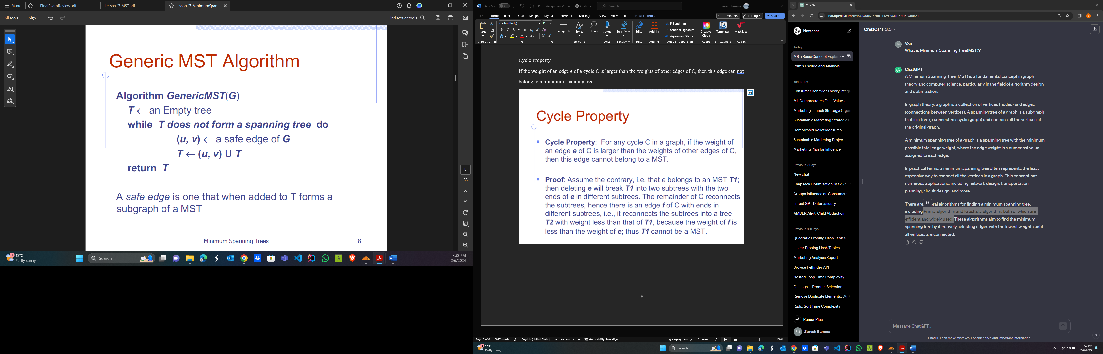

1. How does the Prim’s algorithm works to obtain a MST?

Ans: Refer class notes. The running time is ***O***(***m*** log ***n***) since the graph is connected.

1. write the pseudo code of Prim’s and analyses each step.

Answer: Refer class note.



1. Manually execute the Prim’s procedure for the given tree. Start Vertex A.

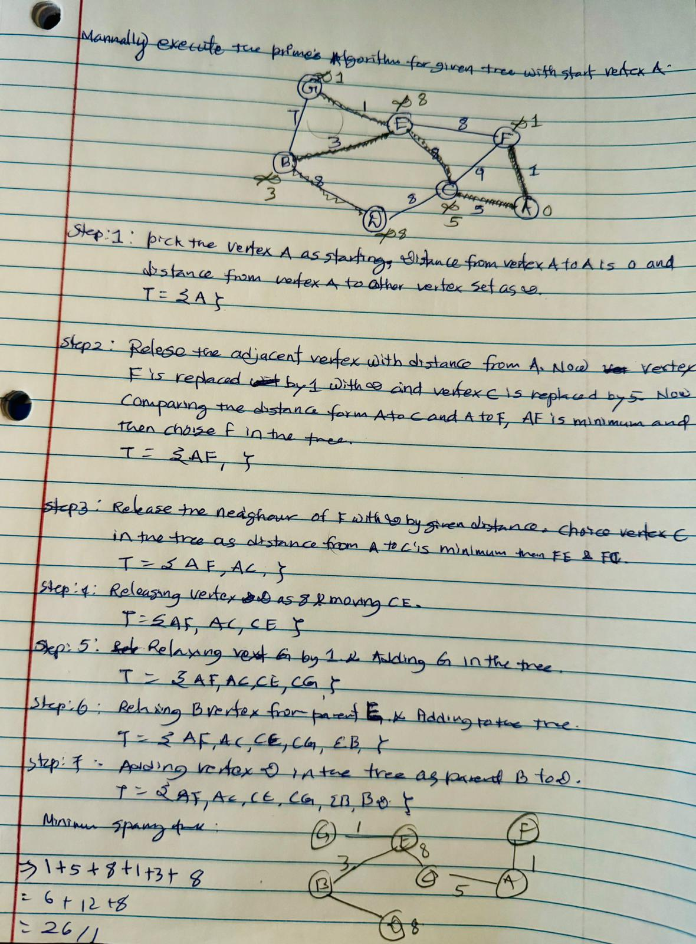

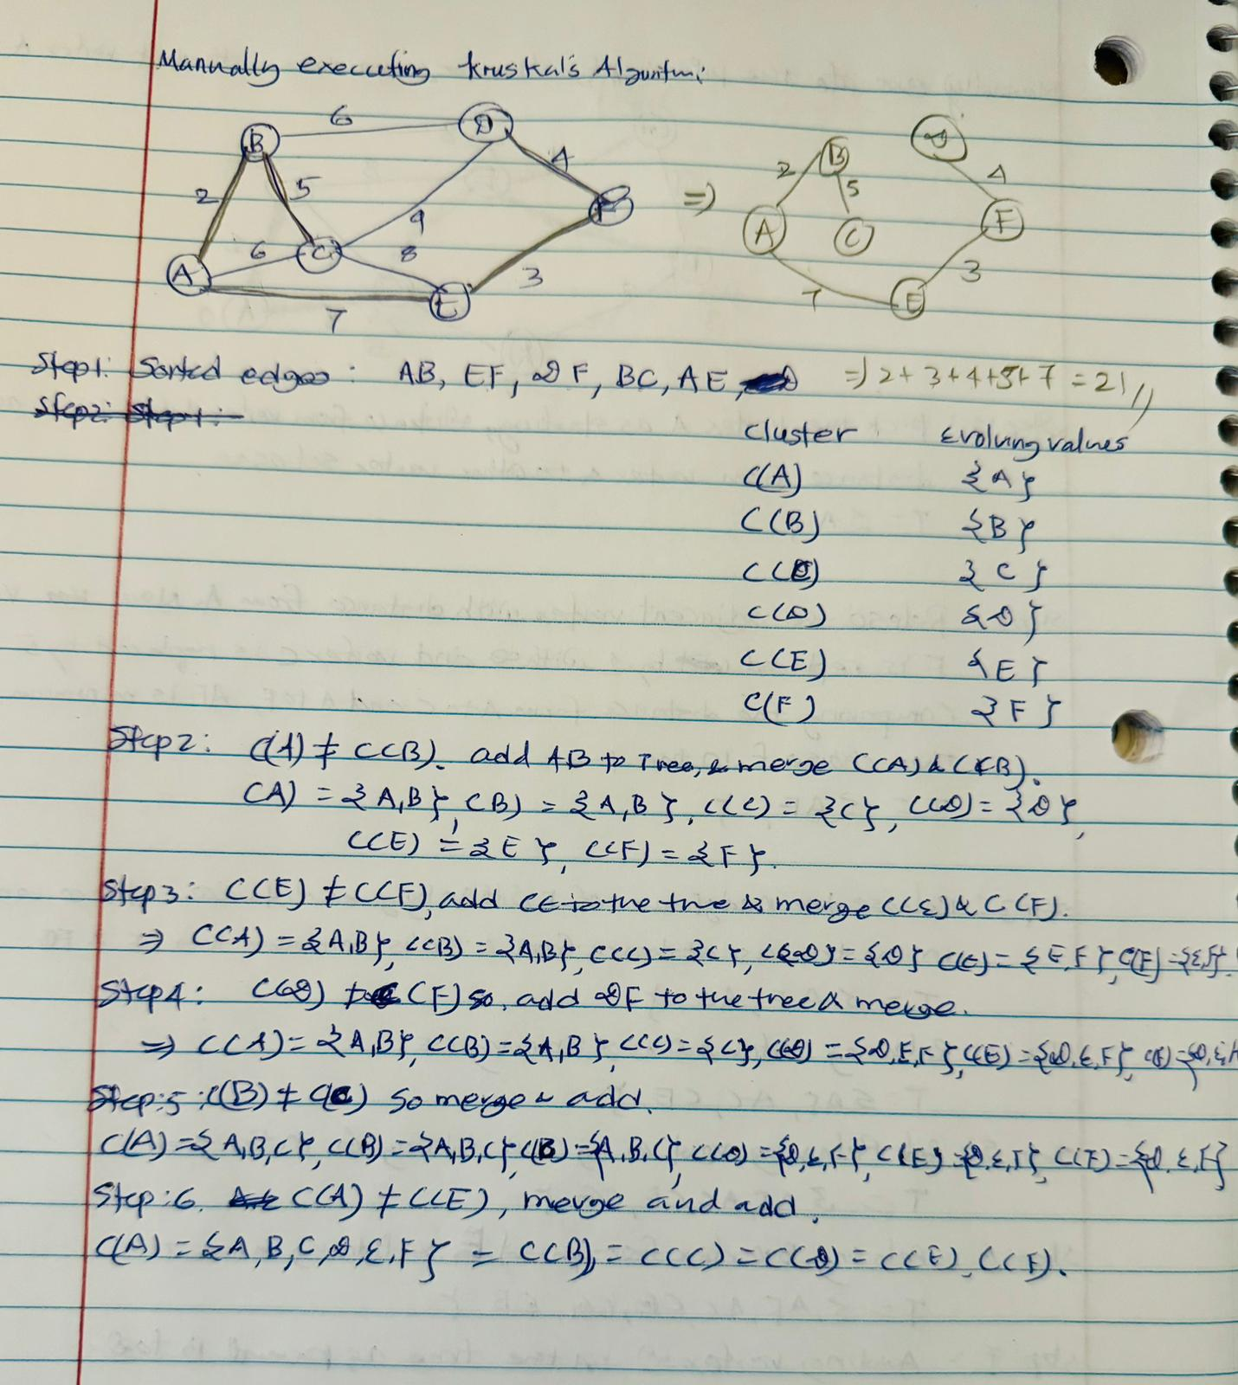

Note: The running time of Kruskal’s algorithm for a graph G = (V, E ) depends on the implementation

of the disjoint-set data structure to check whether two vertices belong to the same tree. They are

called Disjoint Subsets and Union-Find Algorithms. With this approach runtime is O(m log n).

**Greedy Technique:**

1. What is Greedy approach and example problems.

The greedy approach refers to solving problems by making locally optimal choices at each step with the hope of finding a global optimum solution. Some examples of graph problems that can be solved using a greedy approach include:

1. Minimum Spanning Tree (MST): As discussed earlier, Prim's algorithm and Kruskal's algorithm are greedy algorithms used to find the minimum spanning tree of a graph.
2. Shortest Path Problems: Dijkstra's algorithm: It finds the shortest path from a single source vertex to all other vertices in a weighted graph with non-negative edge weights. It uses a greedy approach by selecting the vertex with the smallest distance from the source at each step.
3. Explain in detail how Fractional Knapsack problem applying Greedy approach. Able to analyze its time complexity?

Fractional Knapsack problem is a classic optimization problem where you have a knapsack with a fixed capacity and a set of items, each with a weight and a value. The goal is to determine the maximum value of items to put into the knapsack without exceeding its capacity. In the Fractional Knapsack problem, you are allowed to take fractions of items, i.e., you can take a fraction of an item if it maximizes the total value.

Here's how the Fractional Knapsack problem can be solved using a greedy approach:

1. **Calculate the value-to-weight ratio:** For each item, calculate the ratio of its value to its weight. This ratio represents the "bang for the buck" or the efficiency of each item in contributing to the total value of the knapsack.
2. **Sort the items based on their value-to-weight ratios:** Arrange the items in non-increasing order of their value-to-weight ratios. This step allows us to prioritize items that provide the most value relative to their weight.
3. **Fill the knapsack greedily:** Starting with an empty knapsack, consider items one by one from the sorted list. Add items to the knapsack until either the knapsack is full or there are no more items left. If adding the entire item exceeds the knapsack's capacity, take a fraction of it that fits and add its proportional value to the total.
4. **Repeat step 3 until the knapsack is filled or all items are considered:** Continue adding items greedily until either the knapsack is filled or there are no more items left to consider.
5. **Return the total value of the items in the knapsack:** The sum of the values of the items in the knapsack represents the maximum value that can be obtained.

Please refer to the following pictorial view for better understanding. The overall time complexity of the Fractional Knapsack algorithm is O(n log n. This is typically because the items must first be sorted by their value-to-weight ratio before the greedy approach is applied, and sorting can be done in O(n log n) time with comparison-based sorting algorithms like quicksort or merge sort.

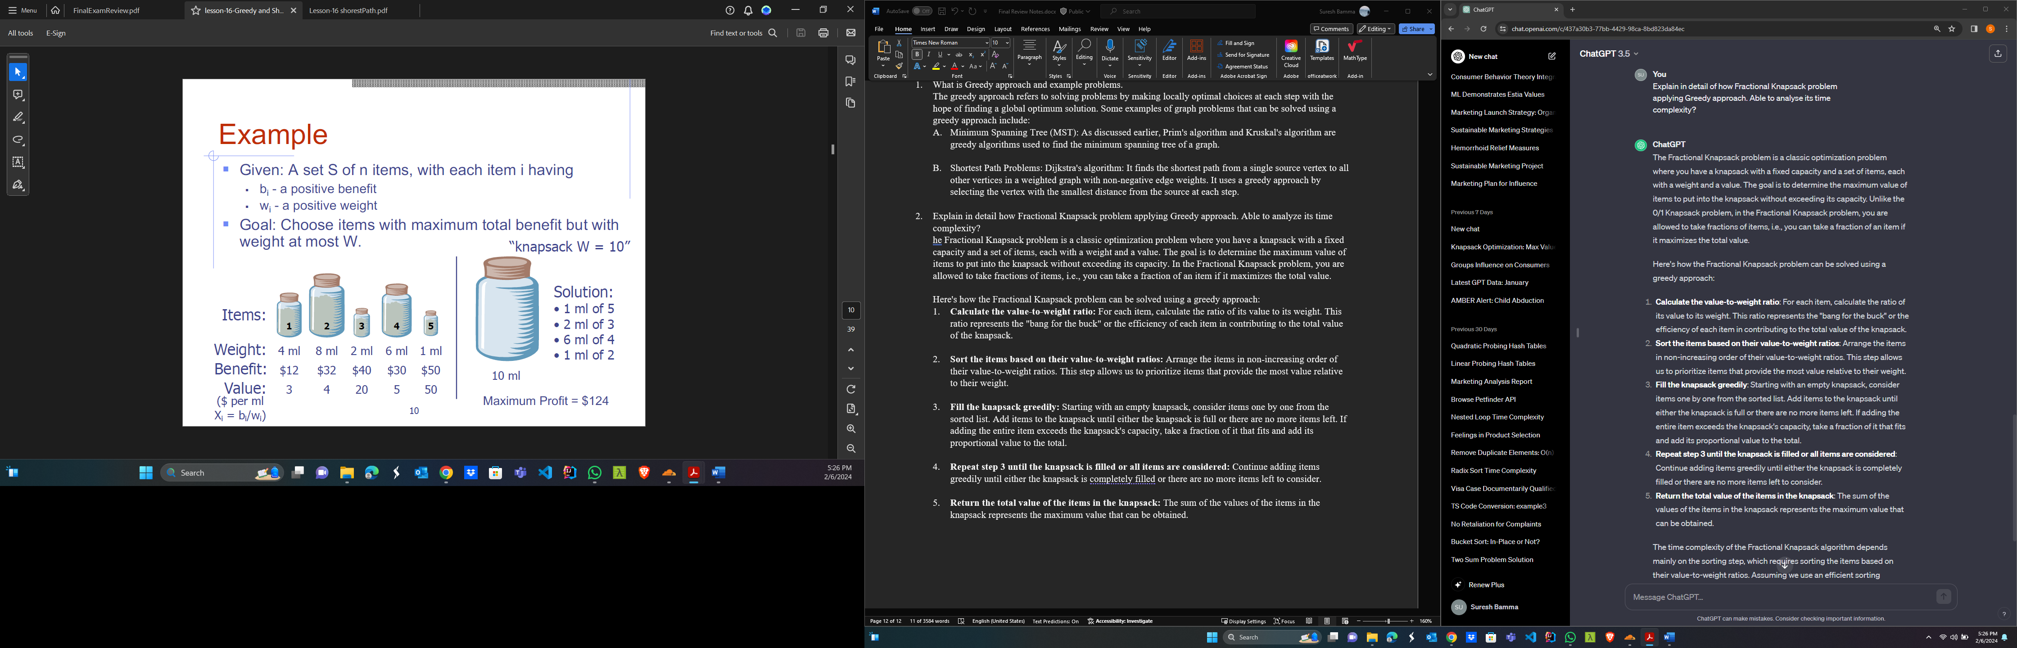

**Shortest Path Properties**

Property 1: A subpath of a shortest path is itself a shortest path

Property 2: There is a tree of shortest paths from a start vertex to all the other vertices.

**Dijkstra’s Algorithm**

The distance of a vertex v from a vertex s is the length of a shortest path between s and v

Dijkstra’s algorithm computes the shortest distances of all the vertices from a given start vertex s

**Assumptions:**

1. the graph is connected
2. the edges are undirected
3. the edge weights are nonnegative

Dijkstra’s algorithm runs in O((m log n) time provided the graph is represented by the adjacency list structure.

